SQL INTERVIEW QUESTIONS
SQL Developer – 4 Years Experience Interview Q&A
1. SQL Basics (Advanced Level)
Q: Difference between INNER JOIN, LEFT JOIN, RIGHT JOIN, FULL JOIN.
- INNER JOIN: Returns only matching rows between tables.
- LEFT JOIN: All rows from left table + matched rows from right.
- RIGHT JOIN: All rows from right table + matched rows from left.
- FULL JOIN: All rows from both tables, unmatched rows filled with NULLs.
Q: UNION vs UNION ALL.
- UNION: Removes duplicates.
- UNION ALL: Keeps duplicates (faster).
Q: EXISTS vs IN.
- EXISTS: Returns true if subquery returns any row. Optimized for correlated subqueries.
- IN: Compares a value against a list/set. For large datasets, EXISTS is usually faster.
Q: GROUP BY vs PARTITION BY.
- GROUP BY: Aggregates rows → one result per group.
- PARTITION BY: Used in analytic functions → keeps all rows but divides them into partitions.
Q: Query to fetch 2nd highest salary.
SELECT MAX(salary)
FROM employees
WHERE salary < (SELECT MAX(salary) FROM employees);
Or using RANK():
SELECT salary
FROM (
SELECT salary, RANK() OVER (ORDER BY salary DESC) rnk
FROM employees
)

WHERE rnk = 2;
Q: Delete duplicates but keep one.
DELETE FROM employees e
WHERE ROWID NOT IN (
SELECT MIN(ROWID)
FROM employees
GROUP BY employee_id
);
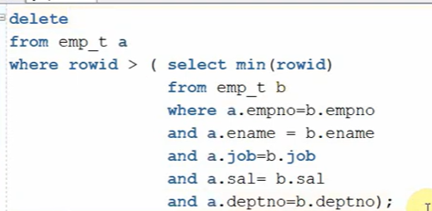
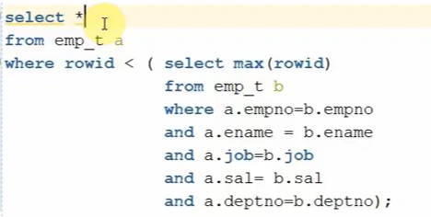

2. Constraints & Keys
- PRIMARY KEY: Unique + Not Null, identifies each row.
- UNIQUE: Only ensures uniqueness, can allow NULLs.
- FOREIGN KEY: Enforces referential integrity between two tables.
- A table can have only one PRIMARY KEY but multiple UNIQUE keys.
- Composite Key: Key made of 2+ columns (e.g., OrderID + ProductID).

3. DML & DDL
- DELETE: Removes rows, can use WHERE, rollback possible.
- TRUNCATE: Removes all rows, no WHERE, cannot rollback.
- DROP: Removes table structure + data.
- MERGE: Used for UPSERT.
MERGE INTO target t
USING source s
ON (t.id = s.id)
WHEN MATCHED THEN UPDATE SET t.name = s.name
WHEN NOT MATCHED THEN INSERT (id, name) VALUES (s.id, s.name);

4. SQL Functions
- RANK: Gives rank with gaps.
- DENSE_RANK: Rank without gaps.
- ROW_NUMBER: Sequential unique numbers.
Example:
SELECT emp_id, salary,
RANK() OVER (ORDER BY salary DESC) rnk,
DENSE_RANK() OVER (ORDER BY salary DESC) drnk,
ROW_NUMBER() OVER (ORDER BY salary DESC) rownum
FROM employees;
NVL: Replace NULL with a value.
COALESCE: Returns first non-NULL (more flexible than NVL).
NULLIF: Returns NULL if two expressions are equal.
SYSDATE vs CURRENT_DATE:
- SYSDATE: Database server date/time.
- CURRENT_DATE: Session time zone aware.

5. Joins & Subqueries
- Employees with no department:
SELECT e.*
FROM employees e
LEFT JOIN departments d ON e.dept_id = d.dept_id
WHERE d.dept_id IS NULL;
- Correlated Subquery: Executes once per outer row.
- Non-Correlated: Executes independently.
- EXISTS vs JOIN: EXISTS is better for checking existence; JOIN is better for retrieving data.

6. Performance Tuning
- Identify slow queries: EXPLAIN PLAN, AUTOTRACE.
- Indexes speed up search by reducing I/O.
- Don’t use indexes for small tables, high DML, or columns with low cardinality (many duplicates).
- B-Tree Index: Good for high-cardinality.
- Bitmap Index: Good for low-cardinality (gender, status).
- Hints: Guide optimizer.
SELECT /*+ INDEX(e emp_idx) */ * FROM employees e;

PLSQL INTERVIEW QUESTIONS
- 7. PL/SQL Basics
- %TYPE: Takes datatype from a column.
- %ROWTYPE: Row structure of a table.
- Record vs Rowtype: Record = custom fields, Rowtype = all columns of a table.
- Exceptions: Handle runtime errors. Predefined (NO_DATA_FOUND), User-defined (custom).
- Function vs Procedure: Function returns a value, Procedure does not.
- Package Spec vs Body: Spec = declarations, Body = definitions.

8. PL/SQL Advanced
- Collections: Associative Array (index by key), Nested Table (unbounded), VARRAY (bounded).
- Methods: .COUNT, .LIMIT, .EXTEND, .TRIM, .EXISTS.
- BULK COLLECT: Fetch multiple rows at once.
- FORALL: Execute DML on collections.
- SAVE EXCEPTIONS: Continue bulk operation even with some errors.

9. Transactions
- COMMIT: Save changes.
- ROLLBACK: Undo uncommitted changes.
- SAVEPOINT: Rollback partially.
- Cannot COMMIT inside function (only allowed in procedures).
- Autonomous Transaction: Independent transaction inside a procedure.
PRAGMA AUTONOMOUS_TRANSACTION;

10. Real-World Scenarios
- Nth highest salary per department:
SELECT * FROM (
SELECT dept_id, emp_id, salary,
DENSE_RANK() OVER (PARTITION BY dept_id ORDER BY salary DESC) rnk
FROM employees
)
WHERE rnk = 3; -- Nth highest
- Employees joined in last 3 months:
SELECT *
FROM employees
WHERE hire_date >= ADD_MONTHS(SYSDATE, -3);
- Incremental load:
SELECT * FROM source
WHERE last_update_date > (SELECT MAX(load_date) FROM target);
- Pivot rows to columns:
SELECT dept_id,
SUM(CASE WHEN gender='M' THEN 1 ELSE 0 END) males,
SUM(CASE WHEN gender='F' THEN 1 ELSE 0 END) females
FROM employees
GROUP BY dept_id;

11. Miscellaneous
- Materialized View: Stores query result physically, can be refreshed.
- View: Virtual, no data stored.
- Partitioning: Splitting table into pieces (Range, List, Hash, Composite).
- OLTP: Transactional DB (frequent inserts/updates).
- OLAP: Analytical DB (queries, aggregations).
- Job Scheduling: DBMS_SCHEDULER or DBMS_JOB.

PLSQL Interview Questions (Beginner to Advanced)
1. Basics
- What is PL/SQL? How is it different from SQL?
- Advantages of PL/SQL.
- Explain the structure of a PL/SQL block.
- Difference between anonymous block, procedure, and function.
- What are variables? How do you declare and initialize them?
2. Data Types & Variables
- Difference between scalar, composite, reference, and LOB datatypes.
- What is %TYPE and %ROWTYPE?
- What is a RECORD in PL/SQL?
- Explain PL/SQL Collections: Associative Array, Nested Table, VARRAY.
3. Control Structures
- Explain IF-THEN, CASE, LOOP, WHILE, FOR loops in PL/SQL.
- Difference between EXIT and CONTINUE.
- Use of GOTO statement.
4. Cursors
- What is a cursor? Types of cursors in PL/SQL.
- Difference between explicit and implicit cursors.
- Attributes of cursors: %FOUND, %NOTFOUND, %ROWCOUNT, %ISOPEN.
- Cursor FOR loop vs explicit cursor handling.
- What is a REF CURSOR?
- Strong vs Weak Ref Cursor.
5. Exceptions
- Types of exceptions in PL/SQL: Predefined, Non-predefined, User-defined.
- Explain NO_DATA_FOUND, TOO_MANY_ROWS, ZERO_DIVIDE.
- How to declare and raise user-defined exceptions.
- What is PRAGMA EXCEPTION_INIT?
6. Procedures & Functions
- Difference between procedures and functions.
- Can we call a function inside SQL statements?
- What are IN, OUT, IN OUT parameters?
- What is overloading in PL/SQL?
- Restrictions on functions inside SQL queries.
7. Packages
- What is a PL/SQL package?
- Difference between package specification and package body.
- Advantages of packages.
- What is package overloading?
8. Triggers
- What is a trigger?
- Types of triggers in PL/SQL (Row-level, Statement-level, BEFORE/AFTER).
- What is the difference between :NEW and :OLD?
- Can a trigger call a procedure?
- Mutating table error – what is it and how to avoid it?
9. Collections & Bulk Operations
- What are collection methods (COUNT, LIMIT, FIRST, LAST, EXTEND, TRIM, DELETE).
- Difference between VARRAY, Nested Table, and Associative Array.
- What is BULK COLLECT? Example.
- What is FORALL? Example.
- What is SAVE EXCEPTIONS in FORALL?
10. Advanced Topics
- What is Dynamic SQL in PL/SQL? Difference between EXECUTE IMMEDIATE and DBMS_SQL.
- What are autonomous transactions? Example.
- Difference between deterministic and non-deterministic functions.
- What is pragma SERIALLY_REUSABLE?
- What is a materialized view log? When is it required?
- Explain DBMS_SCHEDULER and DBMS_JOB.
11. Performance Tuning in PL/SQL
- How to improve PL/SQL block performance.
- Use of BULK COLLECT and FORALL.
- How to reduce context switching between SQL and PL/SQL.
- Use of bind variables.
- Explain native compilation.
12. Real-Time Scenario Questions
- Write a PL/SQL block to fetch Nth highest salary.
- Write a procedure to update employee salary by department.
- Write a trigger to audit changes in a salary column.
- Handle NO_DATA_FOUND and TOO_MANY_ROWS exceptions in a block.
- Write a package with procedures and functions for employee management.

PERFORMANCE TUNING IN ORACLE
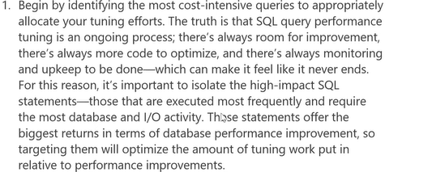
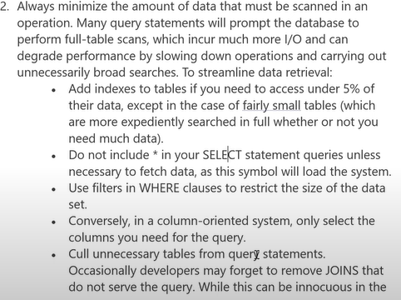
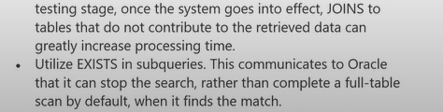
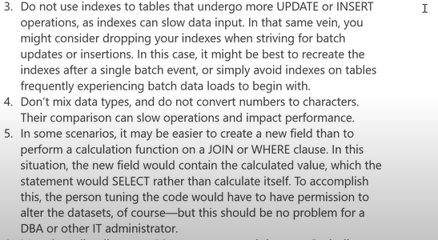
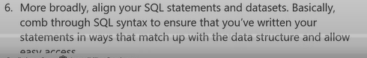
Ie we are dealing with more number of tables, it would be good if we use with clause by creating temperory tables.
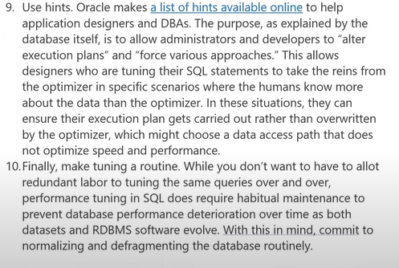

Whenever we are dealing with the huge volume of data, it will take lot of time. In real time projects, we will deal with fact tables. It has the data in TB (Tera Byte).
To Improve the performance, there are different types:
1.Explain Plan – By executing this on particular query, we come to know, how much cost, CPU Performance, Full Table Scan, Range Scan is needed to run this query.
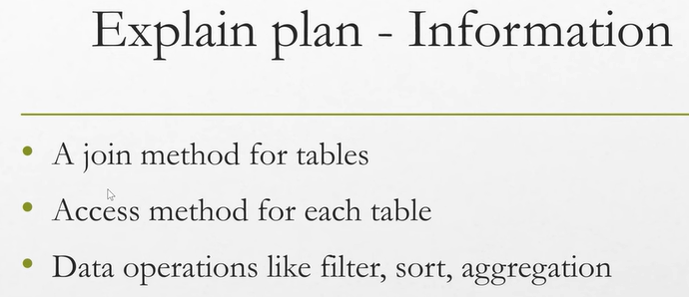
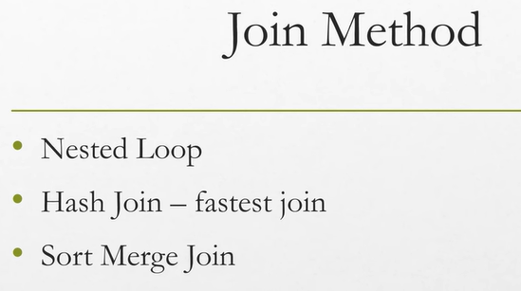
Nested loop -If the two tables are small, it will create loop of the records to check in the joined records in the two tables.
Hash Join- One table in Hash memory, One table is out. It will check by comparing one to one.
Sort Merge Join – One table will be stored in cache and will sort by key column. Based on the sorted order, it will perform join with another table.
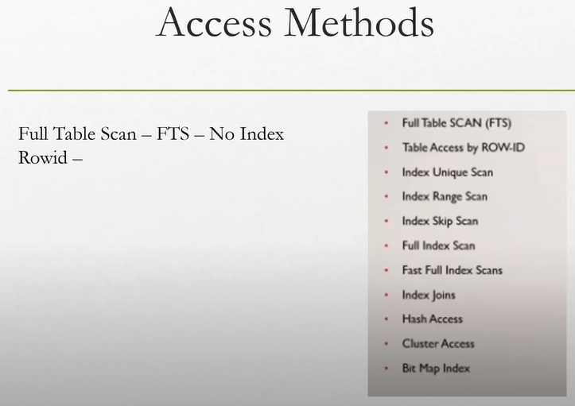
2.Collect Statistics – If we are dealing with big tables (i.e) It contains meta data.
3.Hints –
4.Optimizer – it knows how to run the query. (For Ex: If we are moving from Chennai to Andhra, then we will make one plan like from Chennai to Nellore and Nellore to Andhra. If next time I want to shift from Chennai to Andhra, I will refer the previous plan) like that if we execute the query for the first time, it will store the execution plan of that query and reuses it whenever that query executes
5.Partitioning: (We can run in Enterprise Edition)
To Perform Performance Tuning:
  - Don’t select the tables directly like select * from employees. Because it contains lots of data.
  - Instead of * in the Select Statement - we can list whatever columns we want in select statement. or We can use rownum to check what data is there in the table like select * from employees where rownum<5;
  - Always minimize the data that must be scanned. Use ranges(Date), Filters, Add indexes (if you are not going to insert or update records frequently)

  - Describe the tables to know whether partitioning applied to it or not.
  - Don’t use unused columns.
6.Infrastructure (DBA will take Care) – Increasing Cache, Table Space

SQL UDEMY INTERVIEW QUESTIONS
1. 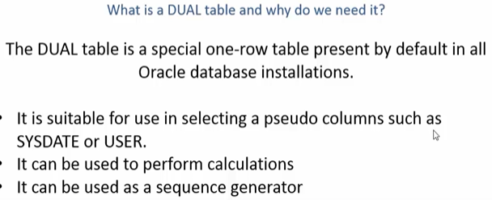
2. 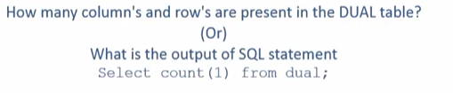One row, One Column.
3. 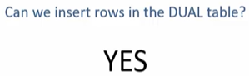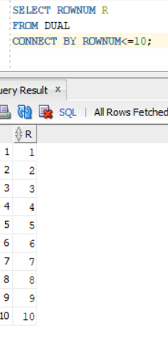
Normally we don’t have privileges. But Database Administrator can insert the records into table. 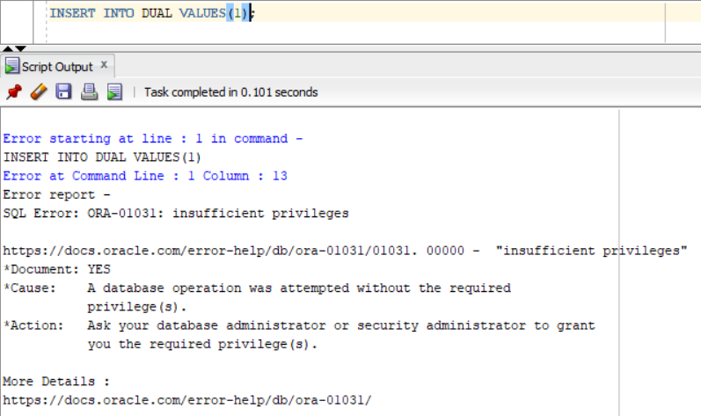
4. 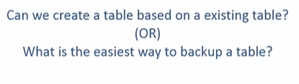
CREATE TABLE TABLE_NAME1 AS SELECT * FROM TABLE_NAME2;
5. 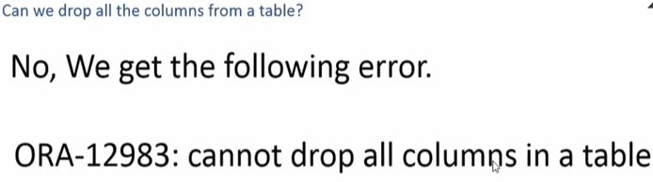
6. 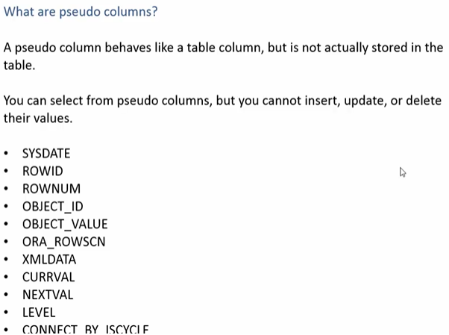
7. 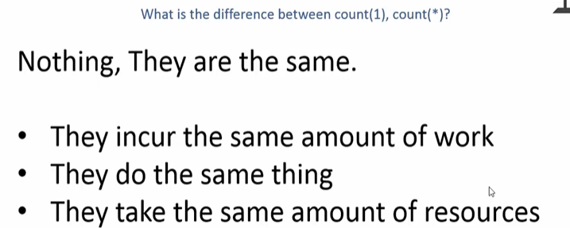

PLSQL UDEMY INTERVIEW QUESTIONS
1.

